# R Exercises

1 The following screenshot plots the child mortality rate in selected countries Use chlmort.csv file to show the relationship between the child mortality rate and Gross Domestic Product (GDP) of a country. **Hint : Use plot function**

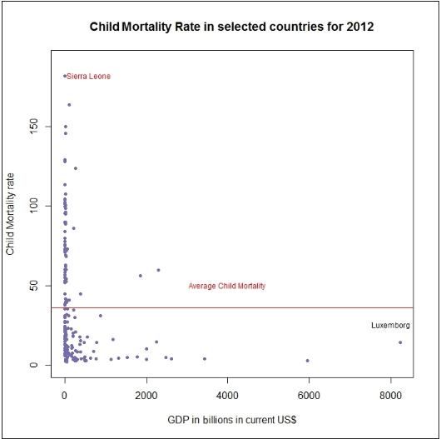

2. Use disable.csv file and generate Gantt Chart that displays periods during which baseball players are disabled. Hint : use gvisTimeline function

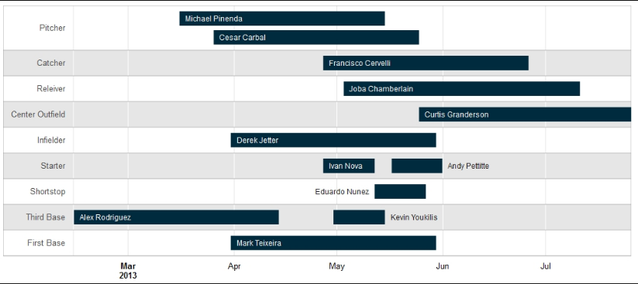

3 Use crimeUSA.csv, googlevis package and gvisBubbleChart function

And show crime per state bubble chart as shown below.

Bubble Size is population

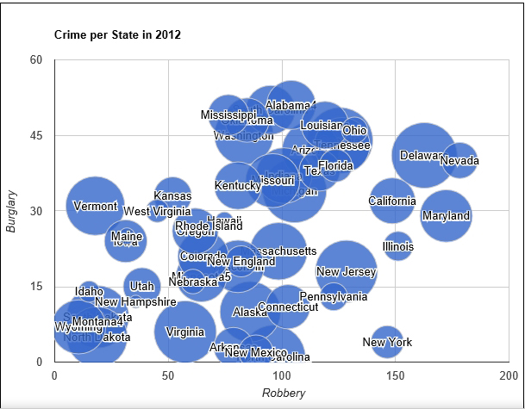

4. Use infant.csv, create Bar graph that displays infant mortality rate of India in 2011. Use Barplot fn

